***+ANUDIP FOUNDATION***

A Project Report on

**RESTAURANT MANAGEMENT SYSTEM**

By

Batch: ANP-C7344

Student ID: AF0368592

Name: Tahura Pathan

**Under the Guidance of**

Mrs. Rajshri Chandrabhan Thete

RESTAURANT MANAGEMENT SYSTEM

Introducing our Java-based Restaurant Management System (RMS):

Efficiently oversee every aspect of your restaurant's operations with our intuitive system. From managing menu items and processing orders to handling reservations and gathering customer feedback, our RMS empowers you to streamline processes and deliver exceptional dining experiences.

**Entities:**

* Admin
* Staff
* Items
* Tables
* Customer
* Order
* Parcel
* Feedback
* Payment

**ATTRIBUTES OF ENTITIES:**

1. **Admin**

* Attributes:
* admin_id (primary key)
* admin_name
* admin_Phone
* admin_Email
* admin_password

1. **Staff**

* Attributes:
* staff_id (primary key)
* staff_name
* staff_rating
* staff_Email

1. **Items**

* Attributes:
* item_id (primary key)
* category
* price
* Name
* Order_count

1. **Customers**

* Attributes:
* customers_id (primary key)
* customer_name
* customer_Phone

1. **Parcel**

* Attributes:
* Parcel_id(primary key)
* item_id (foreign key)
* customer_id (foreign key)
* amount
* order_id
* Time

1. **Orders**

* Attributes:
* order_id (primary key)
* time
* amount
* customer_id(fk)

1. **Tables**

* Attributes:
* Table_number(primary key)
* Total_people
* Time
* customer_id (foreign key)
* item_id (foreign key)
* order_id (foreign key)

1. **Feedback**

* Attributes:
* feedback_id(primary key)
* customer_id (foreign key)
* staff_rating
* staff_id (foreign key)
* item_rating

1. **Payment**

* Attributes:
* Payment_id(primary key)
* Amount
* Payment_type
* Customer_id(foreign key)
* Order_id(fk)
* Payment_date

**ENTITY RELATIONSHIP DIAGRAM - RESTAURANT MANAGEMENT SYSTEM**

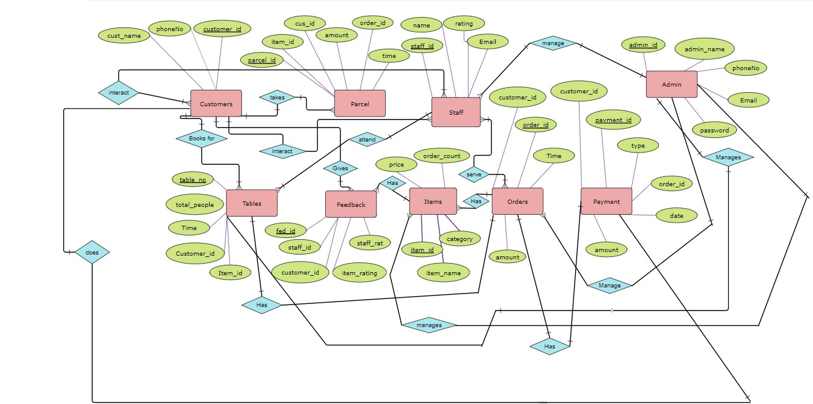

**CONCLUSION:**

In summary, a restaurant management system presents a comprehensive solution aimed at optimizing operations and enhancing the dining experience for both customers and staff. By consolidating data and streamlining administrative processes such as inventory management, staff scheduling, and order tracking, it significantly improves efficiency and accuracy within the restaurant environment. This system fosters better communication among restaurant personnel, leading to smoother workflow and ultimately elevating the quality of service provided to customers. Furthermore, by facilitating timely access to critical information such as menu items, customer preferences, and feedback, it empowers restaurant management to make informed decisions that positively impact business performance and customer satisfaction. Overall, a restaurant management system plays a vital role in modernizing restaurant operations, driving operational excellence, and delivering an enhanced dining experience to customers.

**DATABASE CREATION QUERY:**

**Query OK, 1 row affected (0.01 sec)**

**mysql> CREATE TABLE Admin (**

**-> admin_id INT PRIMARY KEY,**

**-> admin_name VARCHAR(255),**

**-> admin_Phone VARCHAR(20),**

**-> admin_Email VARCHAR(255)**

**-> );**

**mysql> CREATE TABLE Staff (**

**-> staff_id INT PRIMARY KEY,**

**-> staff_name VARCHAR(255),**

**-> staff_rating INT,**

**-> staff_Email VARCHAR(255)**

**-> );**

**Query OK, 0 rows affected (0.02 sec)**

**mysql> CREATE TABLE Items (**

**-> item_id INT PRIMARY KEY,**

**-> category VARCHAR(255),**

**-> price DECIMAL(10, 2),**

**-> Name VARCHAR(255),**

**-> Order_count INT**

**-> );**

**Query OK, 0 rows affected (0.01 sec)**

**mysql>**

**mysql> CREATE TABLE Customers (**

**-> customer_id INT PRIMARY KEY,**

**-> customer_name VARCHAR(255),**

**-> customer_Phone VARCHAR(20),**

**-> customer_email VARCHAR(255),**

**-> customer_password VARCHAR(255)**

**-> );**

**Query OK, 0 rows affected (0.01 sec)**

**mysql> CREATE TABLE Parcel (**

**-> Parcel_id INT PRIMARY KEY,**

**-> item_id INT,**

**-> customer_id INT,**

**-> amount DECIMAL(10, 2),**

**-> order_id INT,**

**-> Time TIMESTAMP,**

**-> FOREIGN KEY (item_id) REFERENCES Items(item_id),**

**-> FOREIGN KEY (customer_id) REFERENCES Customers(customer_id)**

**-> );**

**Query OK, 0 rows affected (0.02 sec)**

**mysql> CREATE TABLE Orders(**

**-> order_id INT PRIMARY KEY,**

**-> time TIMESTAMP,**

**-> amount DECIMAL(10, 2),**

**-> customer_id INT,**

**-> FOREIGN KEY (customer_id) REFERENCES Customers(customer_id)**

**-> );**

**Query OK, 0 rows affected (0.04 sec)**

**mysql> CREATE TABLE Tables (**

**-> Table_number INT PRIMARY KEY,**

**-> Total_people INT,**

**-> Time TIMESTAMP,**

**-> customer_id INT,**

**-> item_id INT,**

**-> order_id INT,**

**-> FOREIGN KEY (customer_id) REFERENCES Customers(customer_id),**

**-> FOREIGN KEY (item_id) REFERENCES Items(item_id),**

**-> FOREIGN KEY (order_id) REFERENCES Orders(order_id)**

**-> );**

**Query OK, 0 rows affected (0.04 sec)**

**mysql> CREATE TABLE feedback(feedback_id INT NOT NULL PRIMARY KEY,**

**-> Staff_rating INT,**

**-> customer_id INT,**

**-> staff_id INT,**

**-> item_rating VARCHAR(255),**

**-> FOREIGN KEY (customer_id) REFERENCES customers(customer_id),**

**-> FOREIGN KEY (staff_id) REFERENCES staff(staff_id)**

**-> );**

**Query OK, 0 rows affected (0.05 sec)**

**mysql> CREATE TABLE payment (**

**-> payment_id INT PRIMARY KEY AUTO_INCREMENT,**

**-> payment_type VARCHAR(50) NOT NULL,**

**-> amount DECIMAL(10, 2) NOT NULL,**

**-> customer_id INT,**

**-> FOREIGN KEY (customer_id) REFERENCES customers(customer_id)**

**-> );**

**Query OK, 0 rows affected (0.05 sec)**

**mysql> show tables;**

**+----------------------------------------+**

**| Tables_in_restaurant_management_system |**

**+----------------------------------------+**

**| admin |**

**| customers |**

**| feedback |**

**| items |**

**| orders |**

**| parcel |**

**| payment |**

**| staff |**

**| tables |**

**+----------------------------------------+**

**9 rows in set (0.00 sec)**